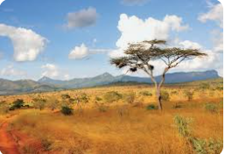


Geography
Autumn 1 – Local Area Study – Awesome Aston
Summer 2 - Kenya
History
Autumn 2 – The Great Fire of London
Spring 2 - Schools
Summer 1 – The Titanic
Science
Autumn 1 – Animals and Living things
Autumn 2 - Materials
Spring 1 – Healthy Lifestyles
Spring 2 – Lifecycles
Summer 1 – Habitats
Summer 2 – Plants

RE
Autumn 1 – What is the good news Christians believe Jesus brings? (Gospel)
Spring 1 – Who is a Muslim and how do they live? (Islam)
Spring 2 - Why does Easter matter to Christians? (Salvation)
Summer 1 – Who is a Muslim and how do they live? (Islam)

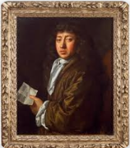

Computing
Autumn 1 – Digital photography
Autumn 2 – Making music
Spring 1 – Pictograms
Spring 2 -Programming Quizzes
Summer 1 – Technology around us
Summer 2 – Robot algorithms
Year 2 Curriculum Overview

RSHE
Autumn 1 – C1: How do we make a happy school? C2: Who lives in my neighbourhood? Water Safety - Swimming pool rules
Autumn 2 - Fr4: How do we stop bullying? Os2: Personal Information (S1) Os3: Online Strangers
Spring 1 – Fa2: Do families always stay the same? Fa3: How should families treat each other? P3: How do we stop getting ill?
Spring 2 – Fa4: When should I say no? Fa5: Who owns my body? I do! G1: Will I always be a child? (Science Link)
Summer 1 - Os4: Fake news (N1) (IL) M2: Who am I? P4: How can I stay safe? Water Safety - Fly the flag
Summer 2 - C3: What makes a boy or a girl? Fa6: Are all families the same? C4: How do I save up to buy something?


DT
Autumn 2 – Christmas Stockings
Spring 1 – Food
Summer 2 – Wheels and axels (Safari Jeeps)

PE

Autumn 1 – Locomotion; Object Control
(throwing & catching)
Autumn 2 – Locomotion; Object Control
(ball control)
Spring – Balance (Gymnastics & Dance); Locomotion (Team Games)
Summer 1 - Athletics
Summer 2 – Athletics; Object Control
(Striking & Fielding)

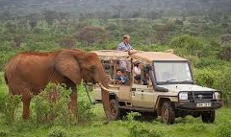
Art (outcomes & Artist study)
Autumn 1 – Painting (Landscape of Aston)
Autumn 2 – Sketching (Pencils, Charcoal)
Spring 1 – Clay (Pinch pot fruit bowl)
Spring 2 - Printing
Summer 1 – Sketching (Portrait of Thomas Andrews)
Summer 2 – Collage (Laura Yager)

Music
Spring 2 -Animals
Summer 2 – Kenya

